**AUTOMATED FACE RECOGNITION BASED ATTENDANCE SYSTEM**

**A PROJECT REPORT**

***Submitted by***

**M.RAMYA KRISHNAN**

**L.RAJAPRIYA**

**K.RASIKA MALINI**

**K.R.RENUGA KEERTHI**

***in partial fulfillment for the award of the degree***

***of***

**BACHELOR OF ENGINEERING**

***in***

**COMPUTER SCIENCE AND ENGINEERING**

**PSNA COLLEGE OF ENGINEERING AND TECHNOLOGY,**

**DINDIGUL**



**ANNA UNIVERSITY: CHENNAI 600 025**

**APRIL 2020**

**Abstract**

This project involves developing a computer vision system that can automatically recognize and mark attendance by face recognition in a real-time video stream . This has been done by examining situations such as training and testing on a small self- accumulated database, clutter, variations in background, noise, occlusion, computing requirements, etc. In order to test all we assembled a database of approximately 3000 images of 100 images perperson. The anticipated outcome of this project is to develop a computer vision system that can automatically recognize and mark attendance by face recognition in a real-time video stream.

**Acknowledgement**

With warm hearts and immense pleasure, I thank the almighty for his grace and blessings which drove us to the successful completion of the project. I would like to express our gratitude towards our parents for their kind co-operation and encouragement which help me in completion of this project.

We take this opportunity to express our sincere thanks to the respected chairperson **Tmt. K. DHANALAKSHMI AMMAL,** who is the guiding light for all the activities in our college. I would like to express deep gratitude to our pro Chairman **Rtn.Thiru R.S.K RAGURAM, D.A.E, M.COM** and Vice-chairman **Thiru R.S.K SUKUMARAN, B.A** for their continuous support towards the development of the students.

We would like to thank our Principal **Dr. D. VASUDEVAN M.E, Ph.D.** for being a beacon in guiding every one of us and infusing us the strength and enthusiasm to work over successfully.

We express our sincere thanks and heartfelt gratitude to **Dr. D. SHANTHI M.E.,Ph.D.,** Professor and Head, Department of Computer Science and Engineering for hervaluable suggestions and continuous encouragement in the completion of the project work.

This project would not have been possible without the motivation and guidance of **Dr. S.PUSHPALATHA,** Professor, **Dr. M.S.THANABAL,** Professor and our Project Guide **Dr. A. SATHYA SOFIA,** Assistant Professor of the Department of Computer Science and Engineering.

**List of Figures**

Figure 1 StudentRegistrationFlow 23

Figure 2FeatureExtraction 24

Figure 3 GeneratingAttendanceFlow 24

Figure 4 Types OfHaarFeatures 26

Figure 5 Haar Features Applied OnAn image 26

Figure 6 DFD :ContextLevel 35

Figure 7 DFD :Level0 36

Figure 8 DFD : Level 1(1.0StudentRegistration) 37

Figure 9 DFD : Level 1(2.0Image Acquisition) 37

Figure 10 DFD : Level 1(3.0FaceDetection) 37

Figure 11 DFD : Level 1(4.0FaceRecognition) 38

Figure 12SystemInterface 39

Figure 13 SignUp Page 39

Figure 14 Admin Information in signingup page 40

Figure 15 LoginPage Interface 40

Figure 16UnsuccessfulLogin 41

Figure 17SuccessfulLogin 41

Figure 18 Admin LoggedinPage 42

Figure 19Registrationform 42

Figure 20 Registrationformfilled 43

Figure 21FaceRegistration 43

Figure 22 Storage ofregisteredimages 44

Figure 23 Registered student info inExcelsheet 44

Figure 24 Encoding ofregisteredimages 45

Figure 25 Training ofregistered images 45

Figure 26Attendancetime 46

Figure 27 Unknownface identification 46

Figure 28 Generation of Attendance inExcelsheet 47

# Notation

## External Entity

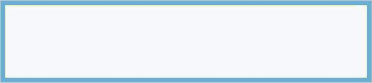

External entities are objects outside the system, with which the system communicates. External entities are resources and destinations of the system's inputs and outputs

## Data Flow



Dataflow is pipelined through which packets of information flow. Label the arrows with the name of the data that moves through it.

## Process



Transform of incoming data flow(s) to outgoing flow(s).

## Data Store

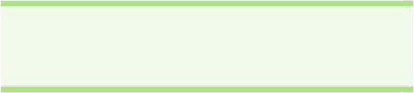

Data stores are repositories of data in the system. They are sometimes also referred to as files, queue or as sophisticated as a relational database.

# Naming and Convention

**ANN** - Artificial neural networks (ANNs) are biologically inspired computer programs designed to simulate the way in which the human brain processes information. ANNs gather their knowledge by detecting the patterns and relationships in data and learn (or are trained) through experience.

**Biometric** - Biometrics is the measurement and statistical analysis of people's unique physical and behavioural characteristics. The technology is mainly used for identification and access control, or for identifying individuals who are under surveillance.

**RFID** - RFID (radio frequency identification) is a form of wireless communication that incorporates the use of electromagnetic or electrostatic coupling in the radio frequency portion of the electromagnetic spectrum to uniquely identify an object, animal or person.

**Machine** learning - Machine learning is a method of data analysis that automates analytical model building. It is a branch of artificial intelligence based on the idea that systems can learn from data, identify patterns and make decisions with minimal human intervention.

**Facial landmarks** - Facial landmark detection is a fundamental step for many tasks in computer vision such as expression recognition and face alignment.

**ROI**- A region of interest (ROI) is a subset of an image or a dataset identified for a particular purpose.

**Classifiers** - refers to the mathematical function, implemented by a classification algorithm, that maps input data to a category.

**Haar cascades** - A Haar Cascade is basically a classifier which is used to detect the object for which it has been trained for, from the source. The Haar Cascade is by superimposing the positive image over a set of negative images.

# Introduction

## BackgroundIntroduction

The current method that institutions uses is the faculty passes an attendance sheet or make roll calls and mark the attendance of the students, which sometimes disturbs the discipline of the class and this sheet further goes to the admin department, which is then updated to an excel sheet. This process is quite hectic and time-consuming. Also, for professors or employees at institutes or organizations, the biometric system serves one at a time. So, why not shift to an automated attendance system which works on face recognition technique? Be it a classroom or entry gates it will mark the attendance of the students, professors, employees,etc.

## CurrentSystems

At present, attendance, marking involves manual attendance on the paper sheet by professors and teachers, but it is a very time-consuming process and chances of proxy are also an issue that arises in such type of attendance marking. Also, there is an attendance marking system such as RFID (Radio Frequency Identification), Biometrics etc. But these systems are currently not that popular in schools and classrooms forstudents.

## Drawbacks in existingsystem

Manual systems put pressure on people to be correct in all details of their work at all times, the problem being that people aren’t perfect, however, each of us wishes we were.

*¬* These attendance systems aremanual.

*¬* There is always a chance of forgery (one person signing the presence of the other one) Since these are manually so there is a great risk oferror.

*¬* More manpower isrequired.

*¬* Calculations related to attendance are done manually (total classes attended in a month) which is prone toerror.

*¬* It is difficult to maintain a database or register in manualsystems.

*¬* It is difficult to search for a particular data from this system (especially if that data, we are asking for, is of very longago).

*¬* The ability to compute the attendance percentage becomes a major task as manual computation produces errors, and also wastes a lot oftime.

*¬* This method could easily allow for impersonation and the attendance sheet could be stolen or lost.

## UsingBiometrics

Biometric Identification Systems are widely used for unique identification of humans mainly for verification and identification. Biometrics is used as a form of identity access management and access control. So the use of biometrics in the student attendance management system is a secure approach. There are many types of biometric systems like fingerprint recognition, face recognition, voice recognition, iris recognition, palm recognition etc. In this project, we have used face recognition system.

## Motivation

The main motivation for this project was the slow and inefficient traditional manual attendance system. So, why not make it automated fast and much efficiently. Also, such face detection techniques are in use by the department of a criminal investigation where the usage of CCTV footages and detecting the faces from the crime scene and comparing them with criminal database to recognize them. It is also becoming as a feature of daily life in China, where authorities are using it on the streets, in subway stations, and at airports.

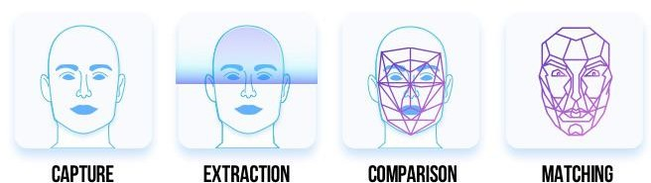

# 2.0 Review of the Literature

Face recognition is such a challenging yet interesting problem that it has attracted researchers from different backgrounds. It is due to this fact that the literature on face recognition is vast and diverse. The earliest work on face recognition can be traced back at least to the 1950s additionally; the research on automatic machine recognition of faces really started in the 1970s, but a fully automatic face recognition system based on a neural network was reported back in 1997.

The aim of all the researches was to make face recognition as automated and accurate as possible through various types of inputs such as static images, video clips, etc. so as to increase its applications in real world. Computational methods of face recognition need to address numerous challenges. These type of difficulties appear because faces are need to be represented in such a way that best utilizes the available face information to define a specific face from all the other faces in the database. Also, extracting such detailed facial features can be used in slandering the search and enhancingrecognition.

The problem of automatic face recognition involves three key steps:

1. FaceDetection
2. Featureextraction
3. Recognition

Sometimes, the steps are not totally separated. For example, the facial features used for face recognition are often used in face detection. Face detection and feature extraction can be achieved simultaneously. Other than that accuracy depends on various factors such as, the nature of the application, size of the training and testing database, clutter and variability of the background, noise, occlusion, and computing requirements, etc. and a fully automatic face recognition system needs to perform all the three steps accurately.

It’s evident that after more than 30 years of research and development, basic 2D face recognition and other image processing applications have reached a mature level and many commercial systems are available for various applications. Some of the major reasons for this success are faster computers, algorithmic improvements, access to large amounts of research tools and datasets, advances in machine learning and perception, the increase in affordable neural networks and now the data-hungry deep learning methods; which have started to dominate accuracy benchmarks around 2011. Various surveys also present factual data indicating that error rates in image processing tasks have fallen significantly since 2012 and are expected to for fall further in nearfuture.

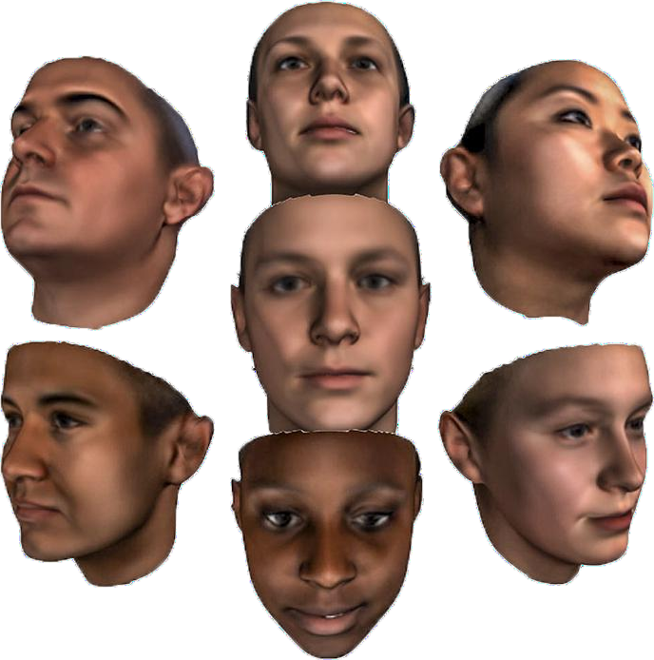

# ProposedSolution

To overcome the problems in the existing attendance system we will develop An Automated Face Recognition attendance system over simple attendance system. There are many solutions to automate the attendance management system like thumb based system, simple computerized attendance system, Iris scanner, but all these systems have limitations overwork and security point of view. Our proposed system shall be a “Face Recognition based Attendance System” which uses the basic idea of image processing which is used in many security applications like banks, airports, Intelligence agenciesetc.

## Proposed SystemComponents

Following are the main components of the proposed system

* + 1. StudentRegistration
    2. FaceDetection
    3. FaceRecognition
       - FeatureExtraction
       - FeatureClassification
    4. Attendance managementsystem.

Attendance management will handle:

* + - * Automated Attendancemarking
      * Manual Attendancemarking
      * Attendance details of users.

## Proposed SystemOutcome

*¬* It will mark attendance of the students via faceId.

*¬* It will detect the faces via wireless camera (IP camera)/webcam and then recognize the faces.

*¬* After recognition, it will mark the attendance of the recognized student and update the attendancerecord.

*¬* The admin will be able to print these record detailsafterward.

## What contribution would the projectmake?

Face recognition is the most natural biological features recognition technology, according to the cognitive rule of human beings; its algorithm is ten times more complex than a fingerprint algorithm. The system will do its work even if one is not in touch with it or forget about it.

Face recognition is featured by the following advantages compared to fingerprint:

1. Accurate and FastIdentification

Industrial Leading Facial Recognition Algorithm, matches more data than a fingerprint, FAR<0.0001%.

1. High Usability andSecurity

Failure to enrol and acquire rate is less than 0.0001%, fingerprint technology will have problems for enrolment with cold, wet, desquamation, elder, and around 5% people cannot get enrolled with a photo which is captured by the camera, there is no evidence with fingerprint technology to track theincident.

1. User friendlydesign

Contactless authentication for ultimate hygiene.

4.0 **PROJECT MODULES :**

* Capturing the Image
* Face Detection
* Image Preprocessing
* Training Set
* Face Recognition
* Attendance marker

**MODULE DESIGN :**

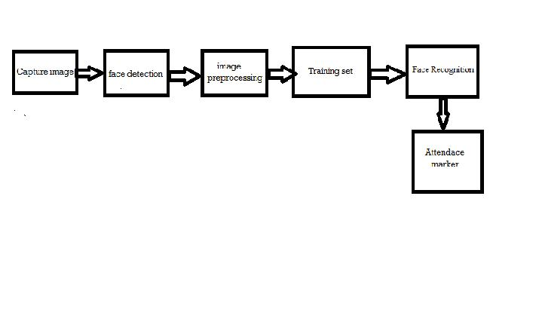

Figure 4.1: Module diagram

1. **Capturing the Image**

The camera will place at the entrance of the classroom to get student's face images perfectly. Then it goes to further process of face detection.

2.**Face Detection**

In this part, implements face detection, which helps to determines captured image with location and sizes of student faces. The image will be captured from detected faces using haar cascade classifier.

3. **Image Preprocessing**

There is a preprocessing requirement for enhance the input image for improve the quality of image .We converts input image to grey scale image using color to grey image conversion technique.

4.**Training Set**

Comparing the faces which to be recognized with some other similar faces to did recognition process. Supply algorithm faces in training set for tell which person who belongs. When recognize face by algorithm, it uses the training set to make recognition.

4. **Face Recognition**

The important part of this system is face recognition. Face recognition of an automatic method of identifying and verifying a person from images and videos from camera.

5. **Attendance marker**

The particular student will be marked as present in attendance when if a face from the particular date folder is matched. That is, collect the list of all students who were present in the class, and rest of the students belongs the class will be marked as absent. This is the following procedure.

**FLOWCHART**

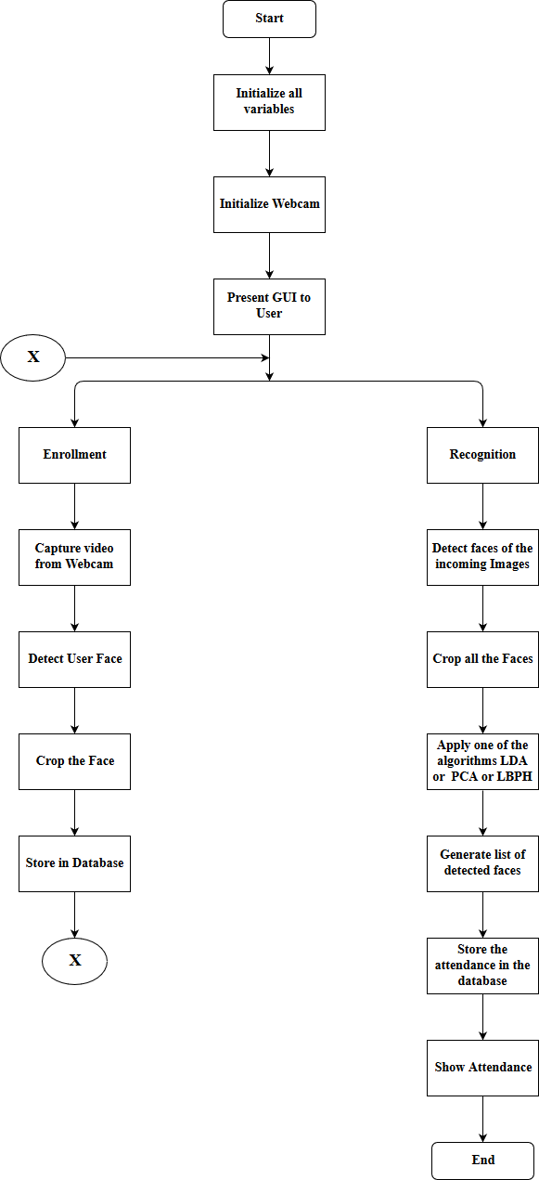

Figure 4.3: Sequence diagram

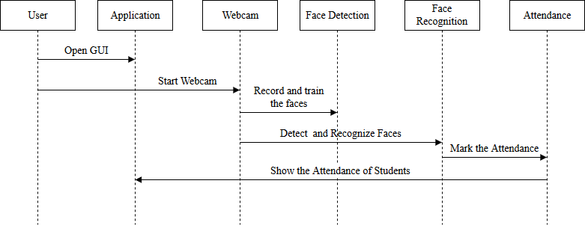**SEQUENCE DIAGRAM:**

Figure 4.3: Sequence diagram

**SYSTEM ARCHITECTURE:**

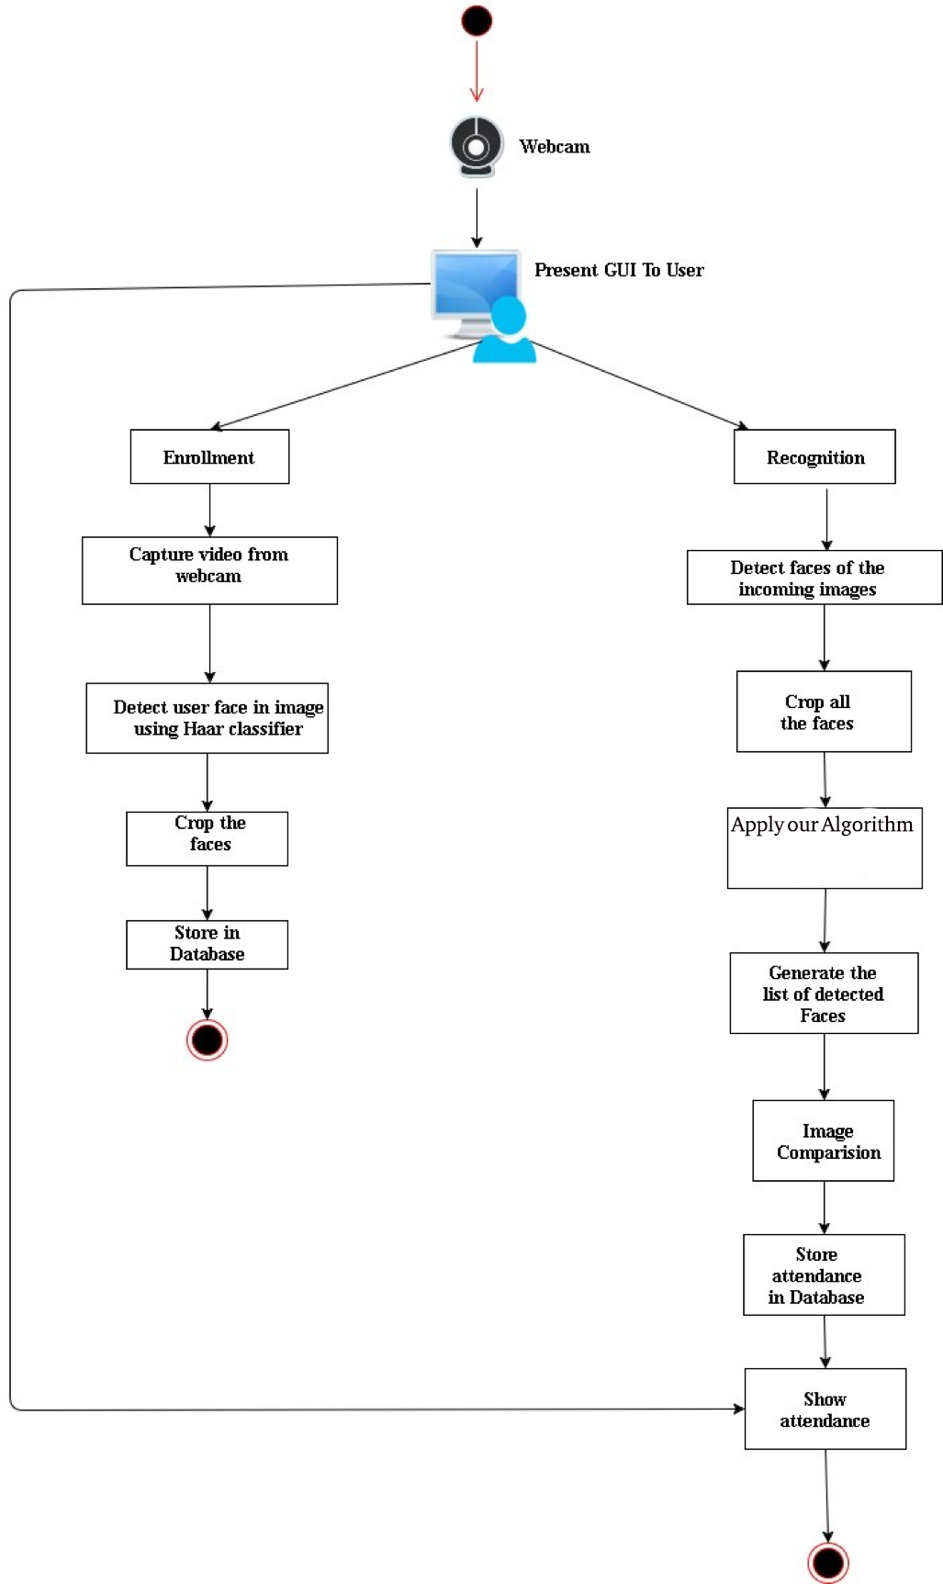

Figure 4.4: System Architecture

**DATA FLOW DIAGRAM:**

**CONTEXT LEVEL DIAGRAM:**

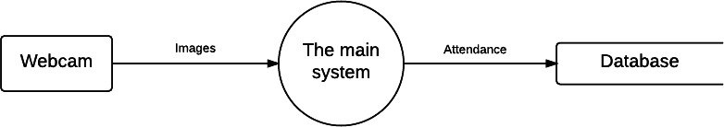

Figure 4.5: DFD Level0

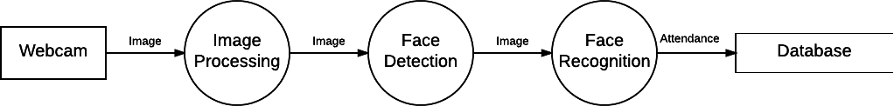

Figure 4.5.1: DFD Level1

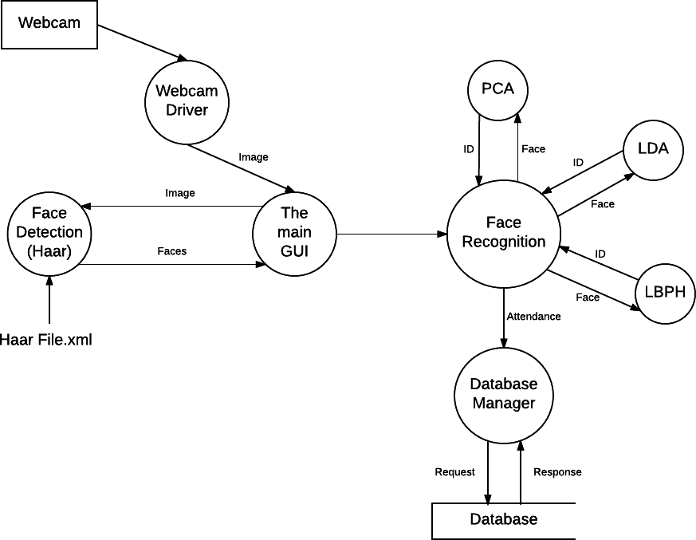

Figure 4.6: DFD Level 2

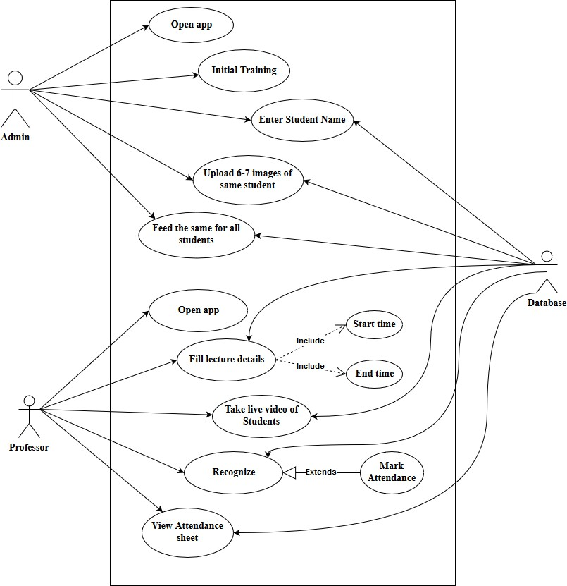**USE CASE DIAGRAM:**

Figure 4.7: USE CASE Diagram

**ComponentDiagram**

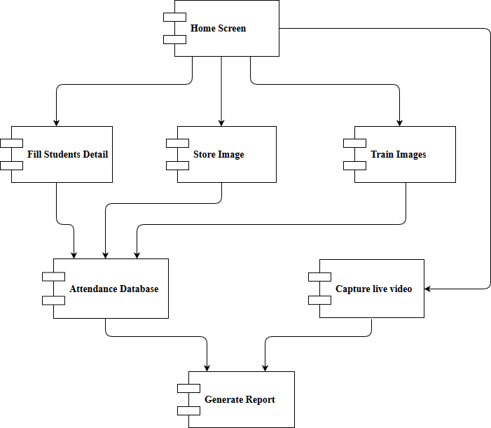

Figure 4.8: Component Diagram

## Project

The face recognition, attendance system is an accurate technology for managing attendance as it hardly gives errors in proper environment with good quality of dataset.

## ProjectScope

*¬* Provides facility for the automated attendance ofstudents.

*¬* Uses live face recognition to recognize each individual and mark their attendance automatically.

*¬* Utilizes video and image processing to provide inputs to thesystem.

*¬* Facility of marking manualattendance.

*¬* Notification via email if there is a lack ofattendance.

## 

## Objectives

* Detection of unique face image amidst the other natural component such as walls and other backgrounds.
* Detection of faces amongst other face characters such as beard, spectaclesetc.
* Extraction of unique characteristic features of a face useful in facerecognition.
* Effective recognition of unique faces in a class (individualrecognition).
* Automated update in the attendance sheet without humanintervention.
* To keep the student updated with their attendanceratio.

## Goals

* To help the lecturers, improve and organize the process of tracking and managing student attendance.
* Provides a valuable attentive service for both teachers andstudents.
* Reduce manual process errors by providing automated and a reliable attendancesystem.
* Increase privacy and security which, student cannot present him or his friend while they arenot.
* Flexibility, lectures capability of editing attendancerecords.

-Reduce time loss as time is a very valuable resource.

## Tools andTechnologies

### Tools

*¬* SoftwareComponents

* + PyCharm
  + MicrosoftExcel

### *¬* HardwareComponents

* + IP camera/WebCamera
  + Computer

### Technologies

*¬* Python

*¬* tinker

### *¬* PyCharmlibraries

* + Pandas: A Python package which provides fast, flexible and expressive data structures and data analysis tools designed to make working with various types of data both easily andintuitively.
  + Pickle: Pickle Module is used for serializing and de-serializing a Python object structure by pickling being the way to convert it into a character stream for it to be saved on disk.
  + NumPy : A library for the Python programming language, adding support for large, multi-dimensional arrays and matrices, along with a large collection of high-level mathematical functions to operatewith.
  + Matplotlib: A plotting library for the Python programming language and its numerical mathematics extensionNumPy.
  + Scipy: It is an open-source Python library used for scientific and technical computing.
  + Random: The random module is another library of functions that can extend the basic features ofpython.
  + Tkinter: An open source Python framework for rapid development of applications that make use of innovative user interfaces, such as multi-touchapps.
  + OpenCV-Python: A Python wrapper for the original OpenCV C++ implementation. OpenCV-Python makes use of NumPy, which is a highly optimized library for numerical operations with MATLAB-style syntax. All the OpenCV array structures are converted to and from NumPyarrays.
  + Six: It provides utility functions for smoothing over the differences between the Python versions with the goal of writing Python code that is compatible on both Pythonversions.
  + Openpyxl : The Openpyxl module allows your Python programs to read and modify Excel spreadsheetfiles.
  + Pyexcel : Provides an application programming interface to read, manipulate and write data in different excel formats and makes information processing involving excel files lesstedious.

# 7.0 System Requirements Specification

## TechnicalRequirement

### HardwareRequirements

* + - A standalone computer (i3 5th Gen, 8gb ram orhigher)
    - High-quality wireless camera to captureimages
    - Secondary memory to store all the images anddatabase

### Softwarerequirements

* + - Pycharm professional 2017.2.4 orhigher
    - Python 3.5 ormore
    - Windows 8 orhigher
    - Latest version of alllibraries

## FunctionalRequirements

System functional requirement describes activities and services that must provide.

*¬* A user must be able to manage studentrecords.

*¬* An only authorized user must be able to use thesystem.

*¬* A system must be attached to wireless camera and face recognition should be smooth.

*¬* The administrator or the person who will be given the access to the system must login into the system before usingit.

*¬* The information must be entered and managedproperly.

## StudentRequirements

*¬* A student needs to enter the proper details while registeringhim/her.

*¬* He/ She needs to sit properly and capture 10-15 images of himself/herself in different directions andexpressions.

*¬* At the time of taking attendance, students need to sit properly facing thecamera.

## Teaching StaffRequirements

*¬* The faculty needs to log into the system at the time of attendance.

*¬* The faculty needs to enter lecture details before starting the attendanceprocess.

*¬* If the entered lecture details don’t match with the ones in the database (excel sheet) an error dialog will bedisplayed.

*¬* As the students are recognized by the system, the attendance report will be generated and shown to thefaculty.

## AdministratorRequirements

*¬* The administrator needs to log into the system at the time of registering the students in the face recognition process.

*¬* He / She must make sure that the student enters the detailsproperly.

*¬* Only the administrator has the rights to manage any changes in thesystem.

*¬* Only the administrator is allowed to view the Training set and the Testingset.

*¬* Only the administrator has the rights to manage any changes in the stored dataset.

# SystemAnalysis

## SystemFlow

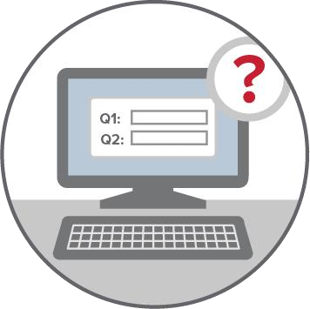

Admin logins the system

Student registration interface provided

Student enters details

The camera is enabled for

capturing face images of the student



On clicking Submit, entered data is stored in the excel workbook





In real-time the student’s face is detected and highlighted on the window

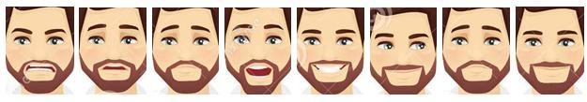

The detected faces are cropped

Cropped faces are stored in the respective student’s name folder



Figure 1 Student Registration Flow

##### FeatureExtraction

Extraction of facial features for comparison

from training set and test image for face recognition

Classifier file

is created based on the stored information

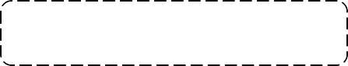

The extracted facial features and the student’s folder name are stored in separate files

Figure 2 Feature Extraction

##### Generating Attendance Flow

Student glances atthe

camera forattendance



Student’s face is detected inreal-time

The facial region of interest is grabbed from the frame

The test image is then classified and the face is identified by comparing it with the training face dataset

The attendance is marked ‘Present’ for recognized student face, rest remains‘Absent’

Figure 3 Generating Attendance Flow

## SystemDescription

Face recognition, attendance system which consists of various phases throughout the completion of the process and is accessed by the administrator. The administrator must be signed up before accessing the system. Login permission is required for the system to be used.

For the student to be recognized they need to be registered. For registration, a form must be filled up with the basic details of a student. Once the form is filled up, 100 images of a student are captured automatically after face being detected as a part of the registration process and are stored in the training set within the particular student folder.

Encoding of the register images takes place. Followed by training of images inside the training set which creates .csv and .pkl file for images that are encoded and their labels.

During attendance, webcam is connected, and as students enter the class their faces are detected and recognized after which, an entry is marked in Excel sheet as a present and other as absent. Unknown faces are shown as ‘Unknown’.

Reports are generated on the basis of attendance sheet monthly .

# ModuleSpecification

## FaceDetection

Detecting facial landmarks is a subset of the shape prediction problem. Facial landmarks such as eyes, eyebrows, nose, mouth, jaw line were used to localize and represent salient regions of the face. Given an input image, a shape predictor attempts to localize key points of interest along the shape. In the context of facial landmarks, our goal was to detect important facial structures on the face using shape prediction methods.

Detecting facial landmarks is therefore involves localizing the face in the image and detecting the key facial structures on the face ROI. Dlib and OpenCV were used to detect facial landmarks in an image.

Face detection has been achieved by us in two ways.

* + - * Using Opencv’s built-in particular HaarCascades.
      * Using a model for predicting facial landmarks.

1. Face detection using Opencv’s HaarCascades

Using the Haar feature-based cascade classifiers is an effective object detection method proposed by Paul Viola and Michael Jones in their paper, "Rapid

Object Detection using a Boosted Cascade of Simple Features" in 2001. It is a machine learning based approach where a cascade function is trained from a lot of positive and negative images. It is then used to detect objects in other images.

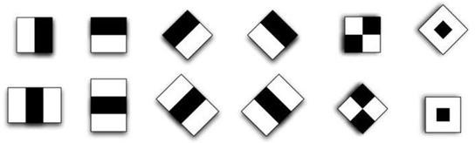

Figure 4 Types of Haar Features

1. Face Detection using a model for predicting faciallandmarks.

The algorithm used to detect the face in the image matter less, instead what matters is given the face region where we can apply facial landmark detector. For detecting key facial structures in the face region we have used a pre-trained facial landmark detector which estimates the location of 68 (x, y)-coordinates that map to facial structures on the face. There are other facial landmark detectors, but all of them try to localize and label the following facial regions: Mouth, Right eyebrow, Left eyebrow, Right eye, Left eye, Nose, Jaw, etc.

## 9.0 Database Design

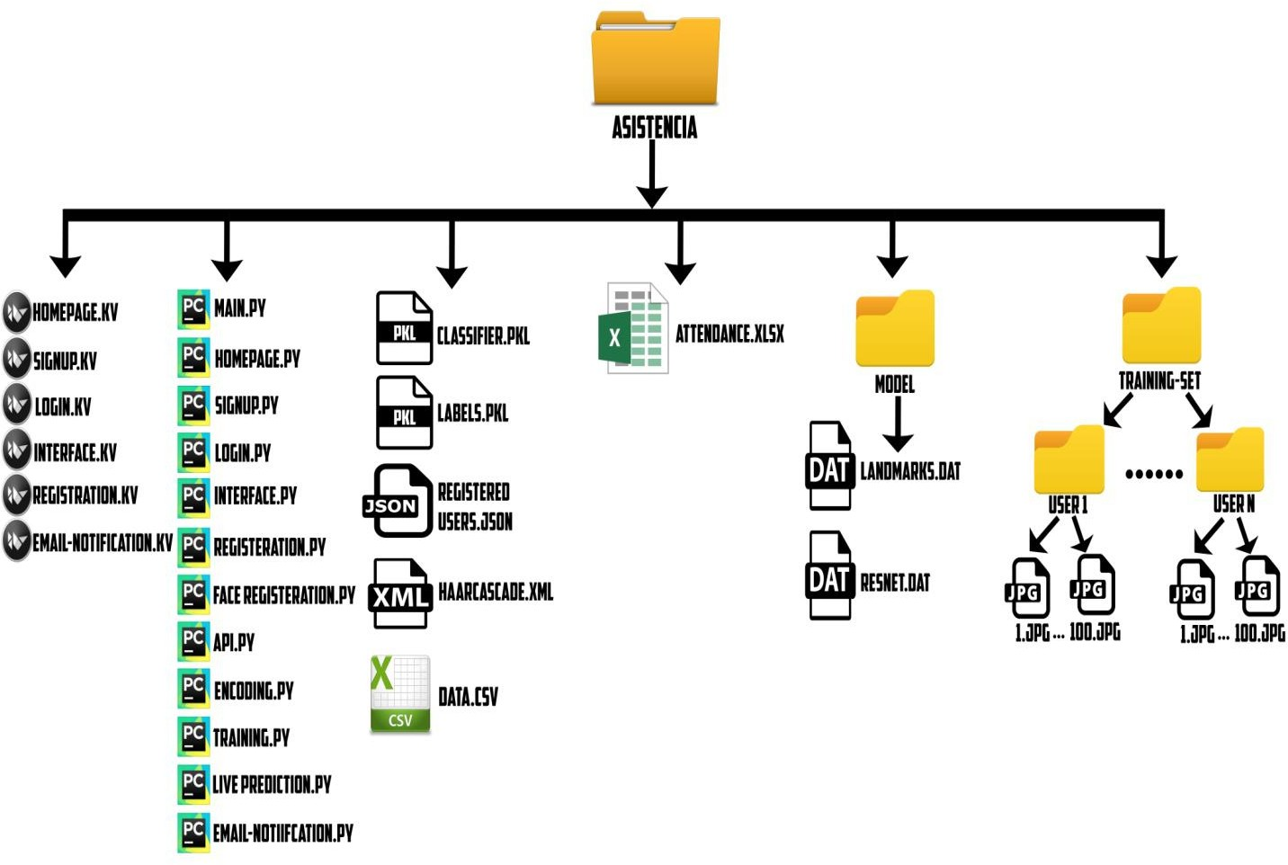

**10.0 Data Flow Diagrams**

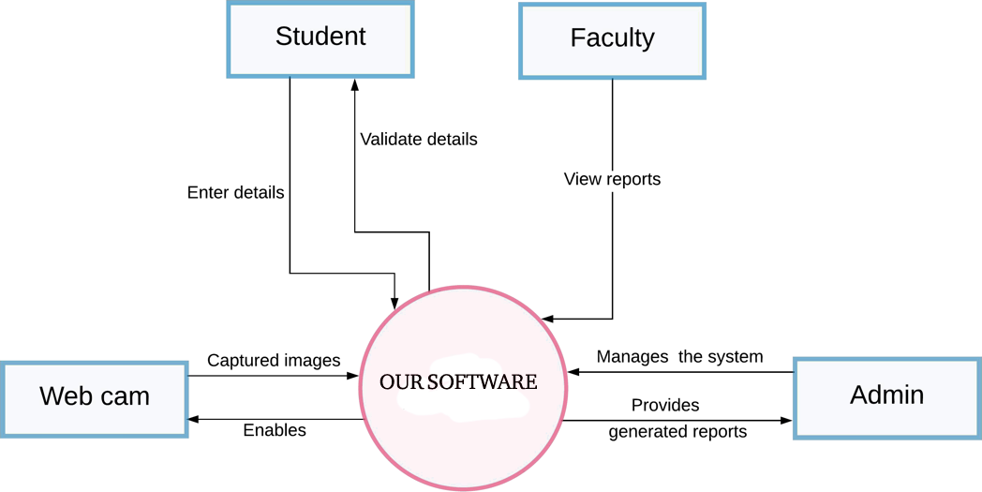

Figure 6 DFD : Context Level

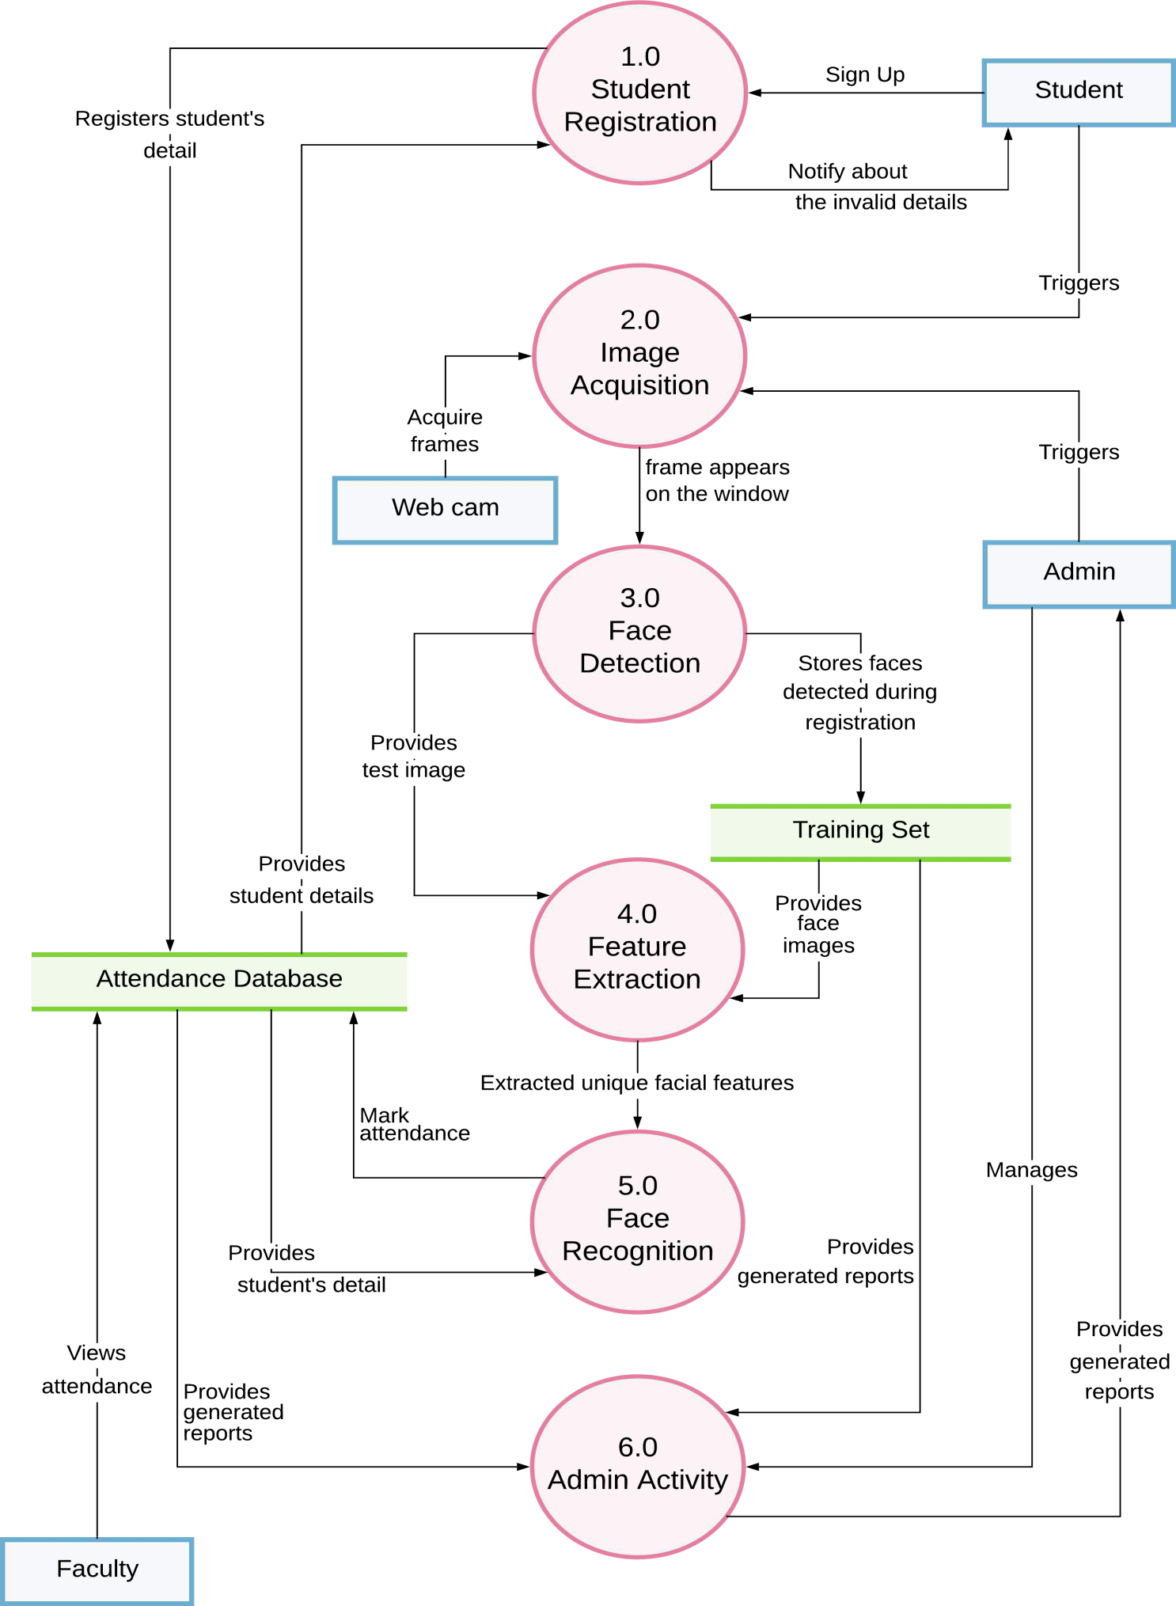

Figure 7 DFD : Level 0

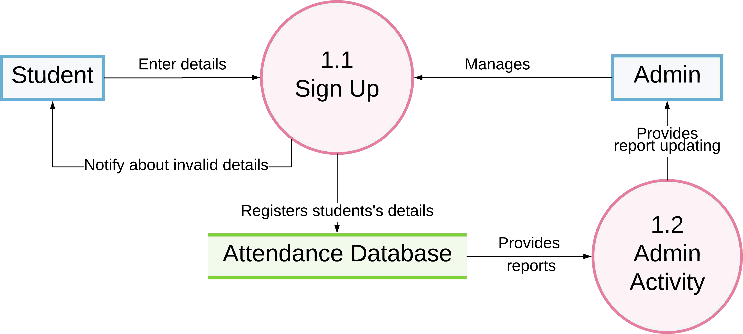

Figure 8 DFD : Level 1 ( 1.0 Student Registration )

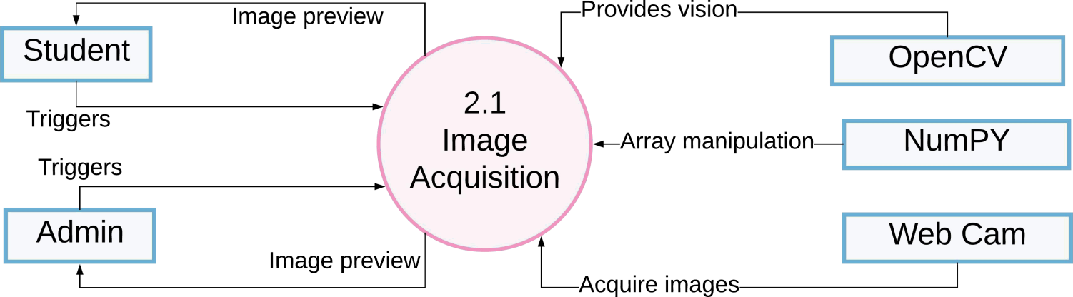

Figure 9 DFD : Level 1 (2.0 Image Acquisition )

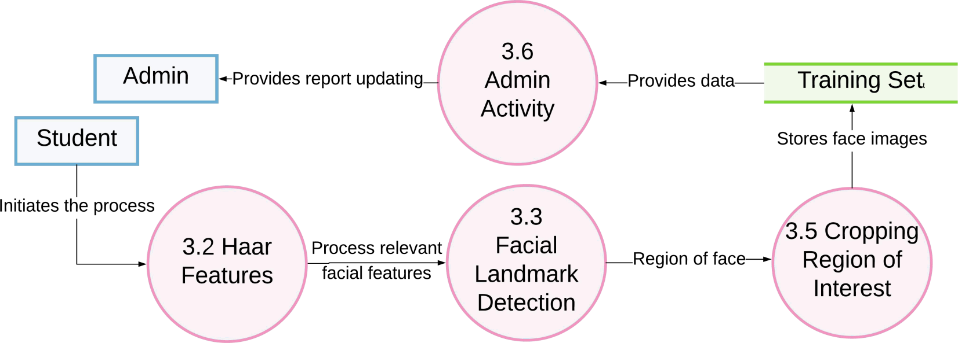

Figure 10 DFD : Level 1 ( 3.0 Face Detection )

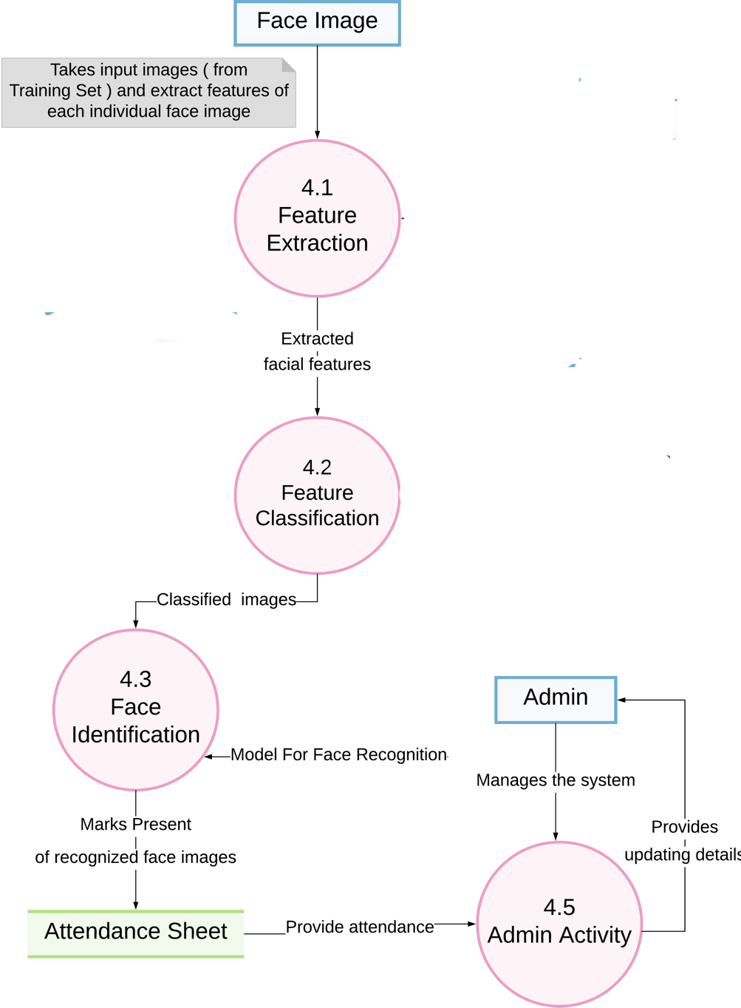

Figure 11 DFD : Level 1 ( 4.0 Face Recognition )

## 11.Project Code

## import tkinter as tk

## from tkinter import Message ,Text

## import cv2,os

## import shutil

## import csv

## import numpy as np

## from PIL import Image, ImageTk

## import pandas as pd

## import datetime

## import time

## import tkinter.ttk as ttk

## import tkinter.font as font

## window = tk.Tk()

## window.title("Face_Recogniser")

## dialog_title = 'QUIT'

## dialog_text = 'Are you sure?'

## window.configure(background='blue')

## window.grid_rowconfigure(0, weight=1)

## window.grid_columnconfigure(0, weight=1)

## message = tk.Label(window, text="Face-Recognition-Based-Attendance-Management-System" ,bg="Green" ,fg="white" ,width=50 ,height=2,font=('times', 25, 'italic bold underline'))

## message.place(x=50, y=20)

## lbl = tk.Label(window, text="Enter ID",width=20 ,height=2 ,fg="red" ,bg="yellow" ,font=('times', 15, ' bold ') )

## lbl.place(x=50, y=150)

## txt = tk.Entry(window,width=20 ,bg="yellow" ,fg="red",font=('times', 15, ' bold '))

## txt.place(x=350, y=165)

## lbl2 = tk.Label(window, text="Enter Name",width=20 ,fg="red" ,bg="yellow" ,height=2 ,font=('times', 15, ' bold '))

## lbl2.place(x=50, y=250)

## txt2 = tk.Entry(window,width=20 ,bg="yellow" ,fg="red",font=('times', 15, ' bold ') )

## txt2.place(x=350, y=265)

## lbl3 = tk.Label(window, text="Notification : ",width=20 ,fg="red" ,bg="yellow" ,height=2 ,font=('times', 15, ' bold underline '))

## lbl3.place(x=50, y=350)

## message = tk.Label(window, text="" ,bg="yellow" ,fg="red" ,width=30 ,height=2, activebackground = "yellow" ,font=('times', 15, ' bold '))

## message.place(x=350, y=350)

## lbl3 = tk.Label(window, text="Attendance : ",width=20 ,fg="red" ,bg="yellow" ,height=2 ,font=('times', 15, ' bold underline'))

## lbl3.place(x=50, y=450)

## message2 = tk.Label(window, text="" ,fg="red" ,bg="yellow",activeforeground = "green",width=100 ,height=2 ,font=('times', 15, ' bold '))

## message2.place(x=550, y=450)

## def clear():

## txt.delete(0, 'end')

## res = ""

## message.configure(text= res)

## def clear2():

## txt2.delete(0, 'end')

## res = ""

## message.configure(text= res)

## def is_number(s):

## try:

## float(s)

## return True

## except ValueError:

## pass

## try:

## import unicodedata

## unicodedata.numeric(s)

## return True

## except (TypeError, ValueError):

## pass

## return False

## def TakeImages():

## Id=(txt.get())

## name=(txt2.get())

## if(is_number(Id) and name.isalpha()):

## cam = cv2.VideoCapture(0)

## harcascadePath = "haarcascade_frontalface_default.xml"

## detector=cv2.CascadeClassifier(harcascadePath)

## sampleNum=0

## while(True):

## ret, img = cam.read()

## gray = cv2.cvtColor(img, cv2.COLOR_BGR2GRAY)

## faces = detector.detectMultiScale(gray, 1.3, 5)

## for (x,y,w,h) in faces:

## cv2.rectangle(img,(x,y),(x+w,y+h),(255,0,0),2)

## sampleNum=sampleNum+1

## cv2.imwrite("TrainingImage\ "+name +"."+Id +'.'+ str(sampleNum) + ".jpg", gray[y:y+h,x:x+w])

## cv2.imshow('frame',img)

## if cv2.waitKey(100) & 0xFF == ord('q'):

## break

## elif sampleNum>100:

## break

## cam.release()

## cv2.destroyAllWindows()

## res = "Images Saved for ID : " + Id +" Name : "+ name

## row = [Id , name]

## with open('.\StudentDetails\StudentDetails.csv','a+') as csvFile:

## writer = csv.writer(csvFile)

## writer.writerow(row)

## csvFile.close()

## message.configure(text= res)

## else:

## if(is_number(Id)):

## res = "Enter Alphabetical Name"

## message.configure(text= res)

## if(name.isalpha()):

## res = "Enter Numeric Id"

## message.configure(text= res)

## def TrainImages():

## recognizer = cv2.face_LBPHFaceRecognizer.create()

## harcascadePath = "haarcascade_frontalface_default.xml"

## detector =cv2.CascadeClassifier(harcascadePath)

## faces,Id = getImagesAndLabels(".\TrainingImage")

## recognizer.train(faces, np.array(Id))

## recognizer.save(".\TrainingImageLabel\Trainner.yml")

## res = "Image Trained"

## message.configure(text= res)

## def getImagesAndLabels(path):

## imagePaths=[os.path.join(path,f) for f in os.listdir(path)]

## faces=[]

## Ids=[]

## for imagePath in imagePaths:

## pilImage=Image.open(imagePath).convert('L')

## imageNp=np.array(pilImage,'uint8')

## Id=int(os.path.split(imagePath)[-1].split(".")[1])

## faces.append(imageNp)

## Ids.append(Id)

## return faces,Ids

## def TrackImages():

## recognizer = cv2.face.LBPHFaceRecognizer_create()

## recognizer.read(".\TrainingImageLabel\Trainner.yml")

## harcascadePath = "haarcascade_frontalface_default.xml"

## faceCascade = cv2.CascadeClassifier(harcascadePath);

## df=pd.read_csv(".\StudentDetails\StudentDetails.csv")

## cam = cv2.VideoCapture(0)

## font = cv2.FONT_HERSHEY_SIMPLEX

## col_names = ['Id','Name','Date','Time']

## attendance = pd.DataFrame(columns = col_names)

## while True:

## ret, im =cam.read()

## gray=cv2.cvtColor(im,cv2.COLOR_BGR2GRAY)

## faces=faceCascade.detectMultiScale(gray, 1.2,5)

## for(x,y,w,h) in faces:

## cv2.rectangle(im,(x,y),(x+w,y+h),(225,0,0),2)

## Id, conf = recognizer.predict(gray[y:y+h,x:x+w])

## if(conf < 50):

## ts = time.time()

## date = datetime.datetime.fromtimestamp(ts).strftime('%Y-%m-%d')

## timeStamp = datetime.datetime.fromtimestamp(ts).strftime('%H:%M:%S')

## aa=df.loc[df['Id'] == Id]['Name'].values

## tt=str(Id)+"-"+aa

## attendance.loc[len(attendance)] = [Id,aa,date,timeStamp]

## else:

## Id='Unknown'

## tt=str(Id)

## if(conf > 75):

## noOfFile=len(os.listdir("ImagesUnknown"))+1

## cv2.imwrite("ImagesUnknown\Image"+str(noOfFile) + ".jpg", im[y:y+h,x:x+w])

## cv2.putText(im,str(tt),(x,y+h), font, 1,(255,255,255),2)

## attendance=attendance.drop_duplicates(subset=['Id'],keep='first')

## cv2.imshow('im',im)

## if (cv2.waitKey(1)==ord('q')):

## break

## ts = time.time()

## date = datetime.datetime.fromtimestamp(ts).strftime('%Y-%m-%d')

## timeStamp = datetime.datetime.fromtimestamp(ts).strftime('%H:%M:%S')

## Hour,Minute,Second=timeStamp.split(":")

## fileName=".\Attendance\Attendance_"+date+"_"+Hour+"-"+Minute+"-"+Second+".csv"

## attendance.to_csv(fileName,index=False)

## cam.release()

## cv2.destroyAllWindows()

## res=attendance

## message2.configure(text= res)

## clearButton = tk.Button(window, text="Clear", command=clear ,fg="red" ,bg="yellow" ,width=20 ,height=2 ,activebackground = "Red" ,font=('times', 15, ' bold '))

## clearButton.place(x=650, y=150)

## clearButton2 = tk.Button(window, text="Clear", command=clear2 ,fg="red" ,bg="yellow" ,width=20 ,height=2, activebackground = "Red" ,font=('times', 15, ' bold '))

## clearButton2.place(x=650, y=250)

## takeImg = tk.Button(window, text="Take Images", command=TakeImages ,fg="red" ,bg="yellow" ,width=20 ,height=3, activebackground = "Red" ,font=('times', 15, ' bold '))

## takeImg.place(x=50, y=550)

## trainImg = tk.Button(window, text="Train Images", command=TrainImages ,fg="red" ,bg="yellow" ,width=20 ,height=3, activebackground = "Red" ,font=('times', 15, ' bold '))

## trainImg.place(x=350, y=550)

## trackImg = tk.Button(window, text="Track Images", command=TrackImages ,fg="red" ,bg="yellow" ,width=20 ,height=3, activebackground = "Red" ,font=('times', 15, ' bold '))

## trackImg.place(x=650, y=550)

## quitWindow = tk.Button(window, text="Quit", command=window.destroy ,fg="red" ,bg="yellow" ,width=20 ,height=3, activebackground = "Red" ,font=('times', 15, ' bold '))

## quitWindow.place(x=950, y=550)

## copyWrite = tk.Text(window, background=window.cget("background"), borderwidth=0,font=('times', 30, 'italic bold underline'))

## copyWrite.tag_configure("superscript", offset=10)

## copyWrite.configure(state="disabled",fg="red" )

## copyWrite.pack(side="left")

## copyWrite.place(x=800, y=750)

## window.mainloop()

## 11.1 System Screenshots

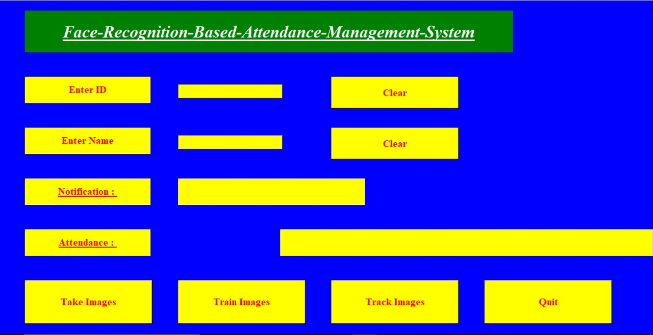

Figure 12 System Interface

Figure 13 index Page

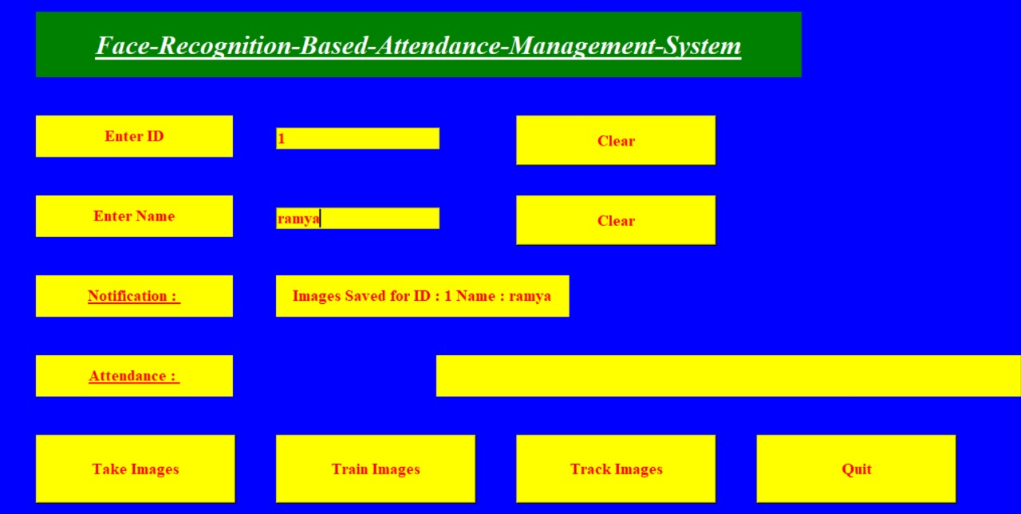

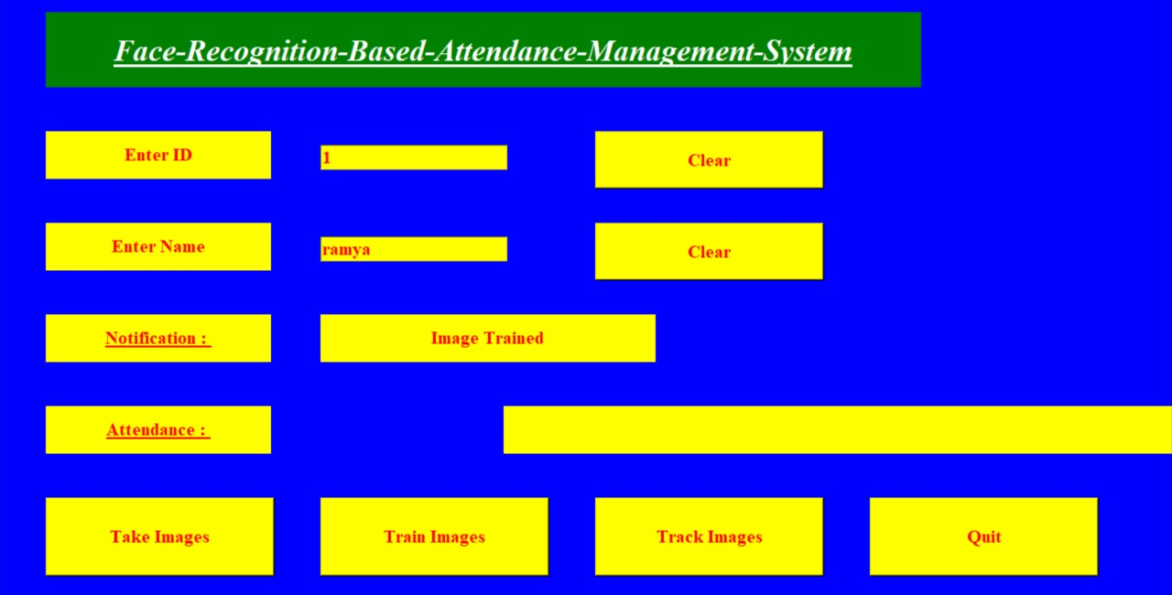

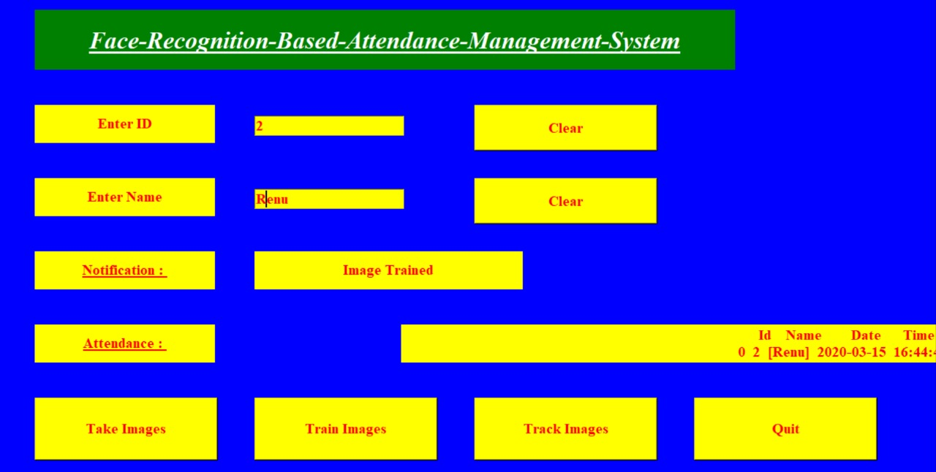

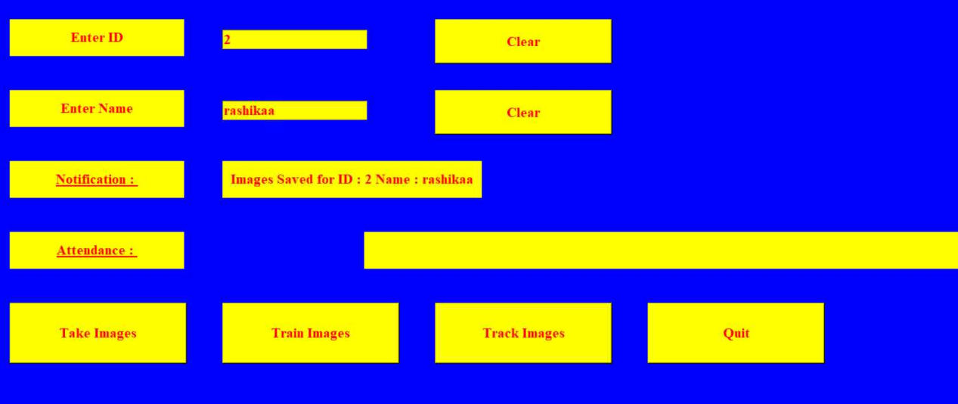

.

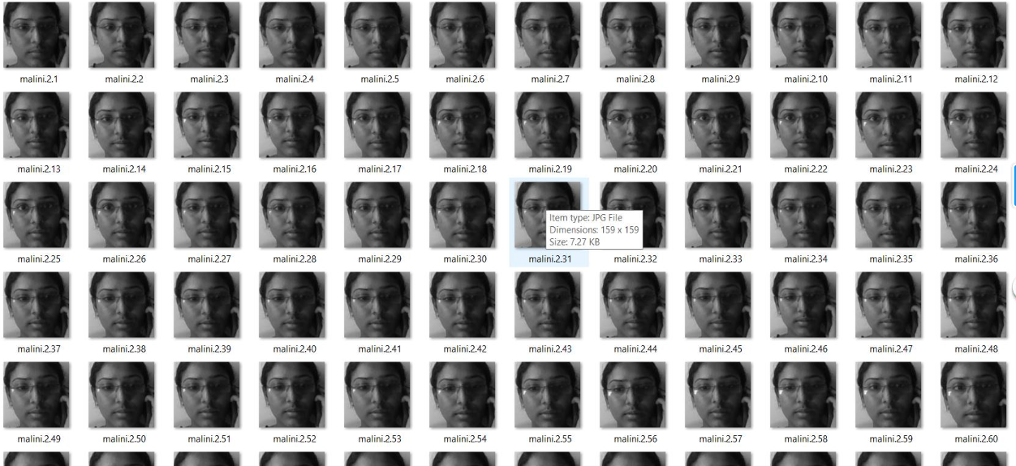

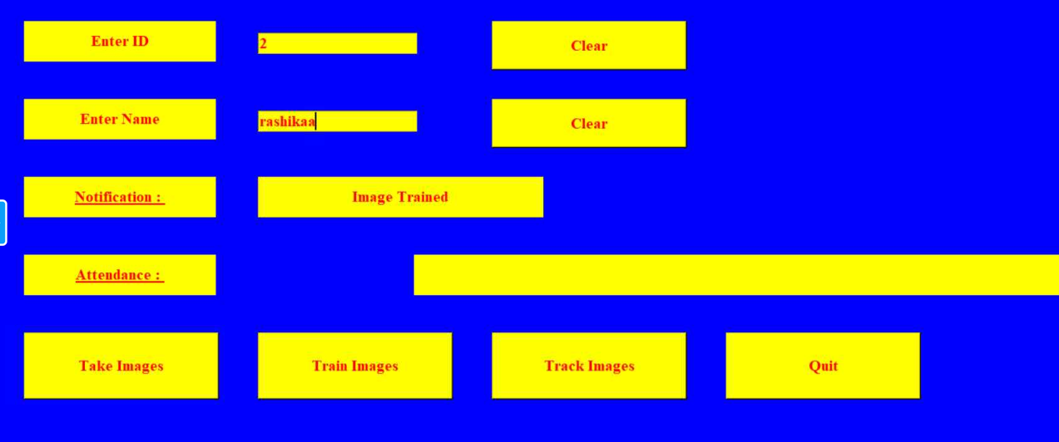

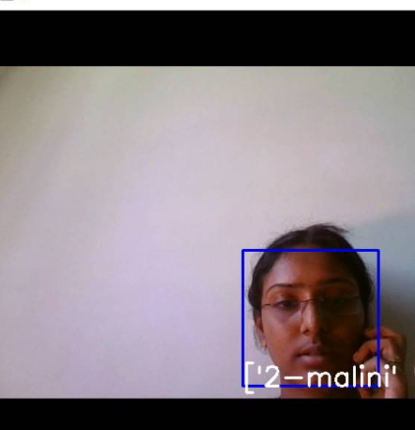

# 12 TESTING

Since the error in the software can be injured at any stage. We had carried out the testing process at different levels during the development. The basic levels of testing are,

* Unit testing
* Integrationtesting
* Validationtesting
* Functionaltesting
* Structural testing

# UnitTesting

Unit testing was used to test individual units in the system and ensure that they operate correctly. Alternate logic analysis and screen validations were tested in this to ensure optimum efficiency in the system. The procedures and functions used and their association with data weretested.

# 12.2 IntegrationTesting

This testing process focuses on identifying the interfaces between components and their functionality. The bottom up approach was adopted during this testing. Low-level modules are integrated and combined as a cluster before testing. This allowed identifying any wrong linkages or parameters passing early in the development process as it just can be passed in the set of data and checked if the result returned is an accepted one.

# 12.3ValidationTesting

Software testing and validation is achieved through a series of block box tests that demonstrate conformity with requirements. A test procedure defines specific test cases that will be used to demonstrate conformity with requirements. Both, the plan and the procedure are designed to ensure that all functional requirements are achieved, documentation is correct and other requirements are met. After each validation test case has been conducted, one of the two possible conditionsexists.

# Functional Testing

Functional testing, also known as block box or closed box testing, is normally applied to HDL (High-Level Data Link) code that operates concurrently and concentrates on checking the interaction between modules, blocks or functional boundaries. The objective here is to ensure that correct results are obtained, when inputs are applied, in a predictable manner.

Functional testing can therefore be considered as concentrating on checking that the data paths operate correctly. The coverage measurements that fall into this category are toggle, triggering, and signal trace coverage.

# Structural Testing

Structural testing, are known as white box or open box testing, is normally applied to sequential HDL (High-Level Data Link) code and concentrates on checking that all executable statements within each module have been exercised and the corresponding branches and paths through that module have been covered.

If there is a section of HDL code that has never been exercised then there is a high possibility that it could contain an error that will remain undetected.

* 1. **Conclusion**

The anticipated outcome of this project was the identification of condition that affects the recognition of faces and to what extent. The results have been classified into different parts.

**14.0 Features of the System**

*¬* Authorized byadministrator.

*¬* Registration of student details andfaces.

*¬* Automatically captures 100 images at the time ofregistration

*¬* Creation of student’s folder where images are stored is created automatically.

*¬* Face are recognized matching with registeredimage

*¬* Unknown persons areidentified

*¬* Excel sheet and sheet is created automatically if notcreated

*¬* Reports are generated as an whenrequired

## 14.1 Benefits

*¬* Ease ofuse.

*¬* Saves time andefforts

*¬* Proxy system is totallyeliminated.

*¬* Used for securitypurposes.

*¬* Multiple facedetection.

*¬* Multiple facerecognition.

*¬* Unknown faces areidentified.

*¬* As the system stores the faces that are detected during registration and automatically marks attendance faster. Providing authorizedaccess.

## 14.2 Limitations

*¬* Expensive

*¬* Difficulties with big data processing and storing without gpu and RAM below 4GB

*¬* Weak camera angle, low-lighting and imagequality.

## 14.3 Future Enhancement

Our has an immensely boundless scope in future. It can be amended as and when requirement emerges, as it is versatile in terms of the extension. There are some facets which can be further modified such as recognized distance can be extended, Graphics processing unit (GPU) can be used for a large amount of the database and quick processing, data storage can be made server-based and can be integrated with multiple cameras at the sametime.